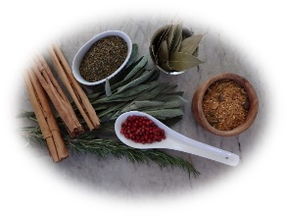Laurales Herbs and Spices

Moving Agreement

The administrative division of Laurales Herbs and Spices is relocating to a new building next week. At our last meeting, you were given detailed instructions on how to prepare your workspace for the move. Below is a brief summary. Print this form. When you have finished packing, sign and date the consent form below and return it to Rachel Enders through interoffice mail. This will assure that all your belongings get to the new location.

|  |
| --- |
| Remove all items from drawers and cabinets. |
| Place items in boxes provided by the movers. |
| Label the boxes with your full name. |
| Use masking tape to label all furniture and equipment. |
| Sign the consent form and return to Rachel Enders. |

I have cleared my workspace, packed and labeled all boxes, furniture, and equipment, and give permission for all items to be moved to the new location.

___________________

Date